IT 357 Crime Scene Research Paper
Bryan Kohberger/Idaho State University Murders

John Murray
3/20/2025

Summary

Overview of the Case

On November 13, 2022, a deadly discovery was made at an off-campus home in Moscow, Idaho when four students attending the University of Idaho were found dead. The four victims were all in their early twenties living in a shared home in close proximity to the campus, their names were Xana Kernodle, Ethan Chapin, Madison Mogen, and Kaylee Goncalves (Associated Press, 2025). Investigators working with the local police and FBI quickly began following Bryan Kohberger, the primary suspect, who was a 28-year-old student studying for his Ph.D. in criminology at Washington State University. Bryan Kohberger was charged with four counts of first-degree murder, one count of burglary, and evidence linking him to the victims and crime (Associated Press, 2025).

The arrest of Kohberger followed an intensive and exhausting investigation relying heavily on surveillance footage, forensic analysis, and digital data. Kohberger’s knowledge in criminology showed that he may have utilized this knowledge to plan and execute these murders, resulting in an added psychological aspect within the investigation (USA Today, 2025).

Review of Evidence

The evidence that was collected throughout this investigation was varied however, the digital evidence had a major role when building the case against Kohberger. There were a few different types of physical and digital evidence collected that connected Kohberger to the crime:

Social media: Kohberger and his social media activity played a large role in the furthering of the investigation. Within hours of the murders taking place, Kohberger went and posted a photo in selfie form on social media throwing up a thumbs up. The image had a clear view of his face and his distinct eyebrows which matched a description of the suspect that was provided by a roommate survivor that had seen him the night the killings took place (New York Post, 2025). In addition to this post, investigators analyzed the behavior of his online presence, which he would often participate in criminology forums where they would talk about criminal behavior and the investigations that take place. This online presence raised questions about what his motives were and if he used his education on criminology to create his plan of actions. He went further than to just study the art of criminology but also to try and understand and even emulate these behaviors of criminals (New York Post, 2025).

Cell Phone Records: Some of the most prolific pieces of evidence would come from Kohberger’s cell phone records, his phone had been connected to a cellphone tower in close proximity to the scene of the crime, all between June and November 2022 (CBS News, 2025). One of the most important pieces of digital evidence was from the night of the murders, his cell phone was traced very closely to the victims’ home in the early hours on November 13th. The phone was disconnected from the network around 3 am and did not reconnect until 5 am near Blaine, Idaho, near Highway 95 south of Moscow (CBS News, 2025). The phones connection and movement brought insight into the timings of the crime further linking Kohberger to the crime. The investigators also used some geo-fencing warrants to analyze any other devices that may have been within the proximity of the murders to assist in the making of the timeline of events. Once obtaining Kohberger’s phone the investigators used forensic tools such as Graykey and Cellebrite that are designed to bypass the security features of a device and collect data that was either deleted or hidden (USA Today, 2025).

Murder Weapon: A key piece of evidence gathered during the investigation was Kohberger’s purchase history on Amazon. The investigators had found that he purchased a Ka-Bar knife and sheath a few months before the murders occurred. When the investigators analyzed the crime scene, they found a knife sheath that had some DNA from Kohberger. Once matching the purchase history together and collecting the DNA, this suggested the direct connection between the knife and the crime (New York Post, 2025). Once discovering the sheath, it presented a piece of physical evidence that linked Kohberger directly to the weapon used for the murders. After further analyzing Kohberger’s search history, the investigators found evidence that he was researching knives and criminology in the months prior to the murders (USA Today, 2025), suggesting that the attack may have been planned.

Surveillance: Multiple sources provided surveillance footage that further confirmed Kohberger’s movements. Investigators tracked a white Hyundai Elantra that was registered to Kohberger and was seen near the crime scene when the murders occurred. The vehicle was then tracked across multiple state lines leading to his inevitable arrest in Pennsylvania. The surveillance cameras in the area with the license plate recognition tech aided the investigators in finding the cars’ location during important times of the crime. Additionally, AI software was used to boost the quality of images and footage that helped the investigators link Kohberger’s car to the scene of the crime (CBS News, 2025).

Crime Scene Investigation Process

The crime scene investigation was a carefully progressed process ensuring that all evidence was preserved correctly. Documenting the scene thoroughly and keeping a log of all evidence obtained is paramount.

Digital Extraction Tools: Digital evidence played a significant role in Kohberger’s connection to the crime. The investigators used forensic tools like Cellebrite and Graykey to retrieve data from his phone while locked under encryption. The tools went past the security of the phone and allowed the investigators to access information with major importance in relation to the crime and crime scene (USA Today, 2025). The extraction of this digital evidence aided investigators in creating a more detailed timeline.

Geo-Fencing Warrants: Geo-fencing was also a useful tool that was used in this investigation. The technique is the investigators request location data of devices near the murder and at the times prevalent to the crime from Google. Using this data, the investigators mapped out Kohberger’s device and the others that were present in the location at the same time, aiding the investigators in their certainty when presenting their evidence. Geo-fencing provided investigators with critical location-based data, corroborating physical evidence and reinforcing the case against Kohberger (USA Today, 2025).

Mistakes or Complications in the Case

Even though the investigation proved to be successful in bringing Kohberger to trial, there were a few complicated times during the investigation.

Arrest Delay: Although pivotal digital evidence was gathered in the early stages of the investigation, Kohberger did not get arrested until about seven weeks after the murders took place. The delay made thoughts that some digital evidence could have been erased or changed in those seven weeks. This also gave Kohberger time to possibly distance himself from the scene of the crime and make changes to his digital presence. Even though the evidence is quite strong, the delay could have hindered the investigation (Associated Press, 2025).

Public Misinformation: During the investigation, lots of misinformation was spread in the press and social media. Details that were not verified were leaked and caused speculation to arise in the public. The interest of the public is inevitable when dealing with these higher-profile cases, however, when false theories are spread they will complicate the true investigation. The investigators had to deal with this misinformation and ensure their information was presented correctly (Associated Press, 2025).

Digital Evidence Difficulties: When handling digital evidence, the difficulties that are presented are real. Digital evidence is very susceptible to deletion and alteration, when ensuring the integrity of digital evidence, for example Kohberger’s phone, it is a very critical topic. In particular, cloud data can come with complications like requiring the investigators to ensure that all social media data and purchase history was handled with extreme care to maintain the integrity of the evidence (USA Today, 2025).

Outcome of the Case

As of March 2025, Kohberger pleads not guilty to all the charges, and the trial is stated to start August 11, 2025, and expected to last around 3 months (USA Today, 2025). The outcome of the case will likely depend on the digital evidence gathered to link Kohberger to the murders. The main case will present cell phone records and data, surveillance footage, social media activity, and the physical evidence found at the scene of the crime like Kohberger’s DNA on the sheath. The defense might choose to challenge the reliability of the gathered evidence and in particular the digital footprints. If Kohberger is to be convicted, he will face a life sentence in prison or arguably the death penalty depending on the charges given (Associated Press, 2025).

Analysis

The investigation of Bryan Kohberger’s case highlighted how modern forensic techniques can show their strengths but show their challenges at times. The law enforcement using the cell phone records, surveillance footage, and digital forensic tools played a significant role when tracking and arresting the suspect. There were delays and challenges when processing and handling the digital evidence that could cause issues within the prosecution. If I was involved in this case, I would have chosen to prioritize a faster timeline for arrest and keep a better control over the collection of digital evidence.

One of the more major issues that occurred was the delay in the arrest of Kohberger, despite having good digital evidence that linked him to the scene of the crime. This could have resulted in altering or erasing evidence during the time that he was free. Especially when you take into account Kohberger’s knowledge in criminology as he most likely understands ways to lessen his digital footprint. Another possible issue that could be brought up from the DNA on the knife sheath could be that there was crime scene contamination due to how difficult it can be dealing with multiple-victim homicides. If I were personally involved I would have tried to have more strict protocol on keeping the evidence well-maintained to prevent any possible legal difficulties.

The legality of digital forensic tools like Cellebrite and Graykey, which were used to retrieve Kohberger’s phone data, raises significant concerns. Courts have examined geo-fencing warrants and extensive digital searches for violations of the Fourth Amendment. The defense may say that certain digital evidence was obtained through intrusive methods. It is crucial to ensure that all warrants are crafted carefully and narrowly defined to prevent disallowed evidence during the trial.

Media speculation also complicated the case when social media began to create false theories and possibly influence the public and possibly in the selection of jury. Additionally, having a media strategy to mitigate some of these issues could become extremely worthwhile.

Finally, while there is a bountiful amount of evidence and it is strong, some of the digital evidence elements can be seen more as circumstantial and not a proof of guilt. This case represents the power that digital forensics possesses but can also show the legal difficulties that come with these procedures. The investigators could have focused some more power into more traditional methods of investigation, although there may not have been enough physical evidence to match the digital evidence. In my eyes, ensuring that there is a faster arrest, a level of evidence handling that cannot be questioned, and to be aware of some of the legal issues that could be brought up with these digital warrants, these are the main things that could improve and strengthen investigations in the future.

Appendix
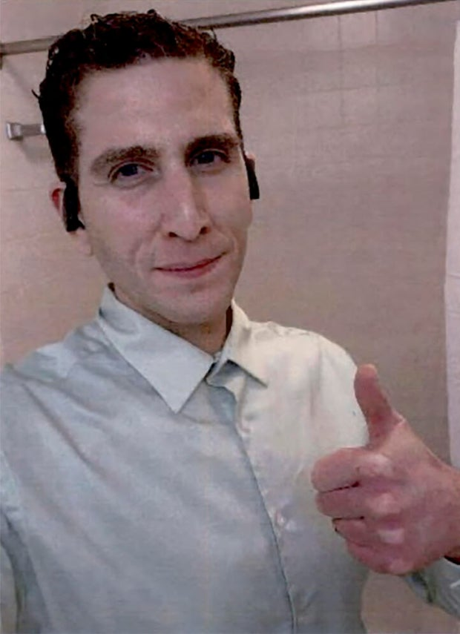
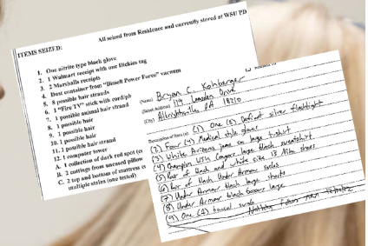
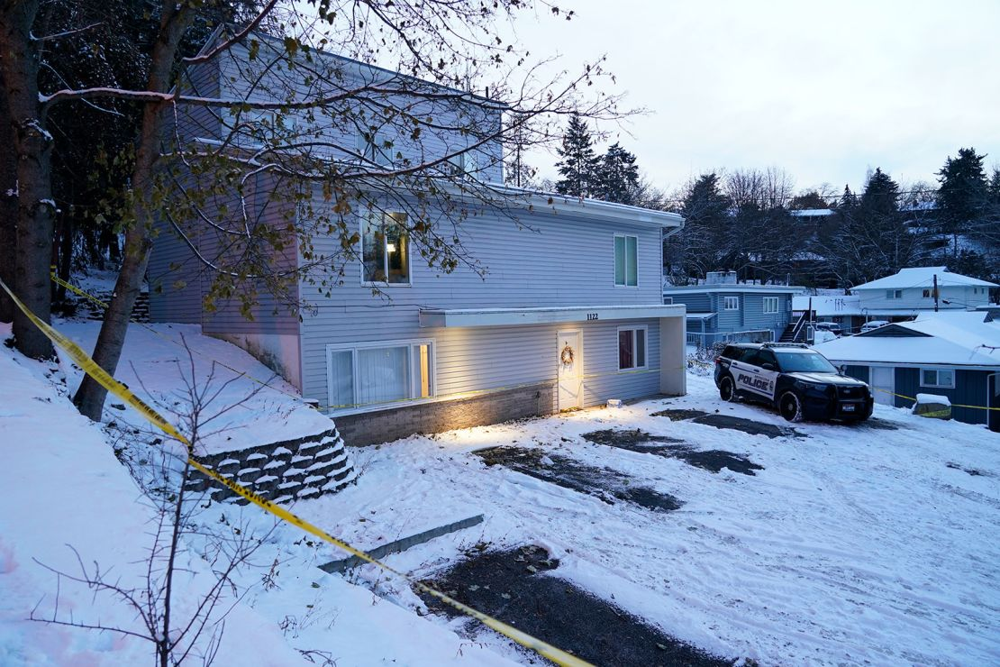
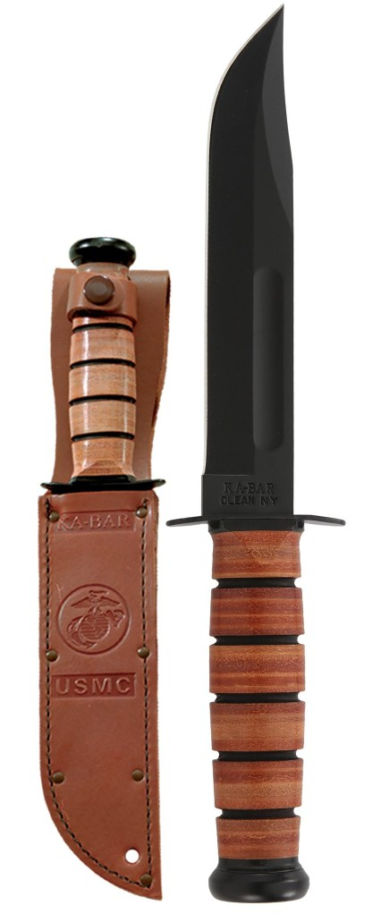
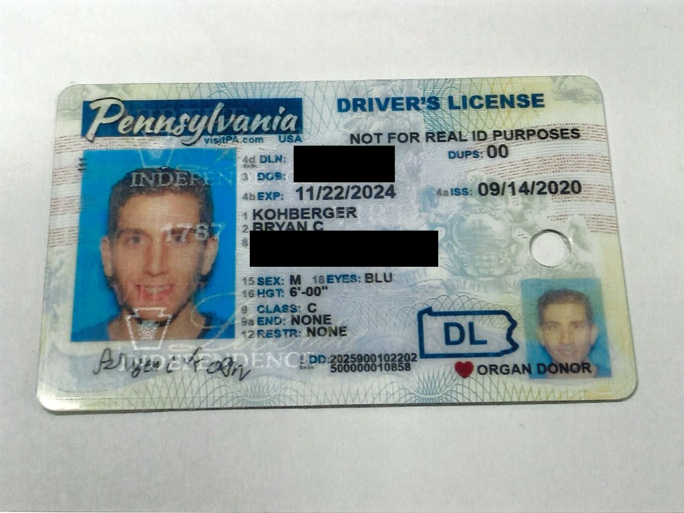

Works Cited

Johnson, G. (2025, March 20). Court filings offer new details in Bryan Kohberger’s quadruple murder case. Here’s what to know. AP News. https://apnews.com/article/bryan-kohberger-university-idaho-stabbing-82f8a6ee9295ea47d1ecb9d2e7954a4a

Crane, E., & McEntyre, N. (2025, March 20). Bryan Kohberger posted creepy selfie hours after Idaho student murders, bought K-Bar knife on Amazon, prosecutors say. New York Post. https://nypost.com/2025/03/20/us-news/bryan-kohberger-posted-creepy-thumbs-up-selfie-hours-after-university-of-idaho-student-murders/

Valle, L. del, & Casarez, J. (2025, March 20). New defense filings shed light on communications by roommates of killed University of Idaho students before 911 call. CNN. https://www.cnn.com/2025/03/20/us/university-of-idaho-roommates-calls-social-media/index.html

Pulver, D. V., Hughes, T., Collins, T., & Santucci, J. (2025, March 22). Timeline: University of Idaho murder case and the arrest of Bryan Kohberger. USA Today. https://www.usatoday.com/story/news/nation/2025/03/22/university-of-idaho-murder-case-bryan-kohberger-timeline/80625554007/?utm_campaign=trueanthem&utm_medium=social&utm_source=facebook&fbclid=IwY2xjawJNVu9leHRuA2FlbQIxMQABHUVIJ_ED-cge7QH5ZyEYetd3mf0vrvgNn-YtuBnk6fnMNU6rXeXJdSANhg_aem_0XlkoB-6eJOHLRwGR-VU2A

CBS Interactive. (n.d.). Idaho murders suspect’s selfie puts focus on evidence citing “bushy eyebrows.” CBS News. https://www.cbsnews.com/news/idaho-murders-suspect-bryan-kohberger-selfie-evidence-bushy-eyebrows/

Romine, T. (2025, March 22). Inside the hours of terror among surviving roommates the night of the Idaho student murders. CNN. https://www.cnn.com/2025/03/22/us/idaho-student-murders-roommates-texts/index.html

‌ Bryan Kohberger Case: DNA, Eyewitness, Evidence, But No Murder Weapon or Motive. (2023, March 7). Inside Edition. https://www.insideedition.com/BRYAN-KOHBERGER-EVIDENCE-DNA-EYEWITNESS-MURDER-WEAPON-MOTIVE

‌

‌

‌

Background Check

To ensure that I am credible as an investigator or as a witness in a case, I first did a simple google search of my name and also age to see if there were any identifications of myself that I could find from a search, and it resulted in me not finding any data there. I then checked my social media accounts for anything that could be used or interpreted in a way against me and as I do not have many social media accounts and the ones I do have I do not post on, there was nothing to report. Finally, I conducted a search for any possible old social media accounts and the only 2 I could find were old Instagram pages from around 8 years ago with no media posted. In conclusion, my findings deemed me to have no conflicting posts or statements that could disallow me to participate.

